

Name Email Phone Event Name:
Address Postcode
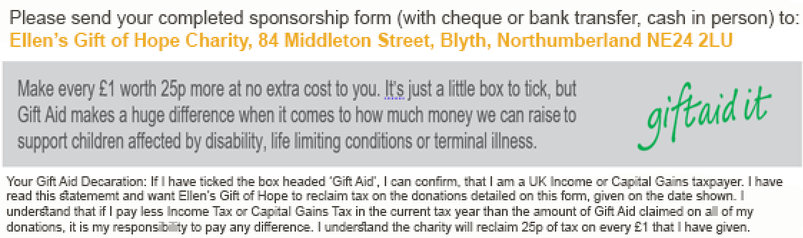

Title | Initials | Surname | House name or number | Postcode | Date of donation | Your donation | Gift Aid  (please tick)
Mrs | J | Smith | 321 A | CR1 3FG | 26.04.13 | £10.00
(Please fill in your name and home address in your own writing – otherwise we can’t claim Gift Aid.)
Total
Date paid to charity
Need more copies? Simply download from www.ellensgiftofhope.org

Title | Initials | Surname | House name or number | Postcode | Date of donation | Your donation | Gift Aid  (please tick)
Total
Date paid to charity
Need more copies? Simply download from www.ellensgiftofhope.org

